Practical No.1
Practical No.1-A : Create a Calculator application using Simple SOAP service. Implement basic arithmetic operations viz. Addition, Subtraction, multiplication and division. Deploy the service and check the execution with passing proper inputs. Create a Web service Client to call all web service methods.

Step1: Create a java web application in NetBeans
Goto file -> new project -> java web -> Web Application
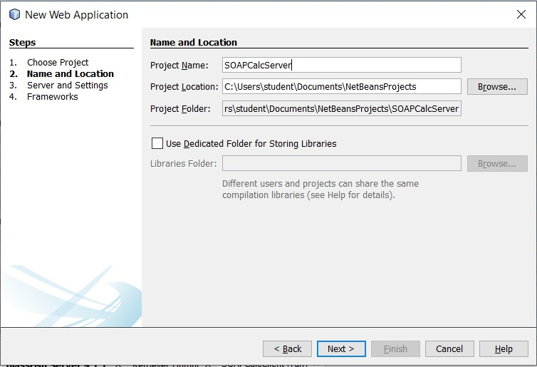
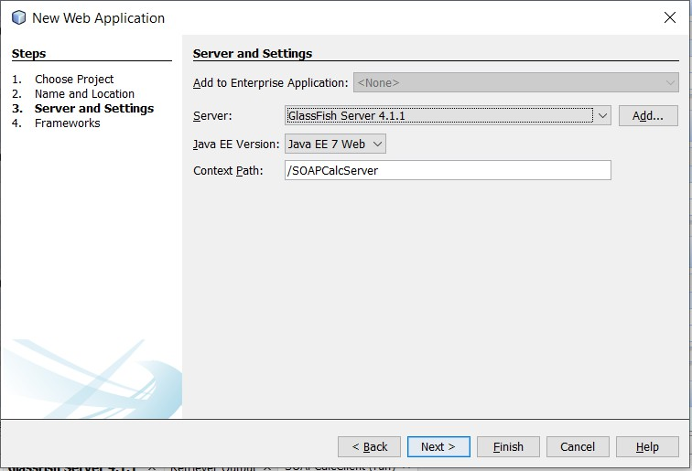

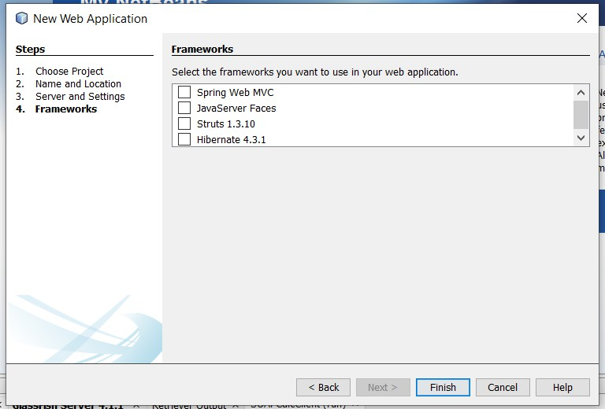
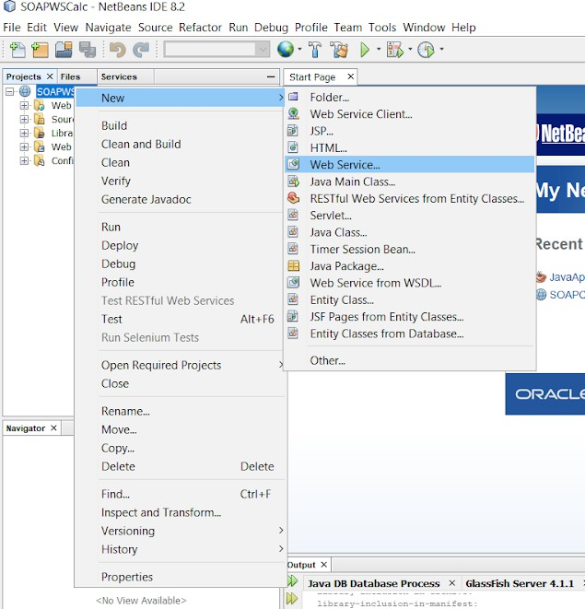
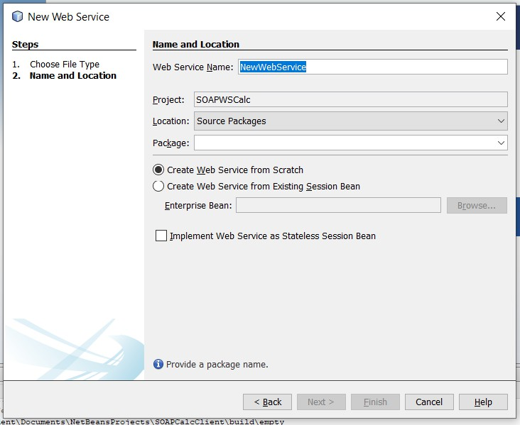

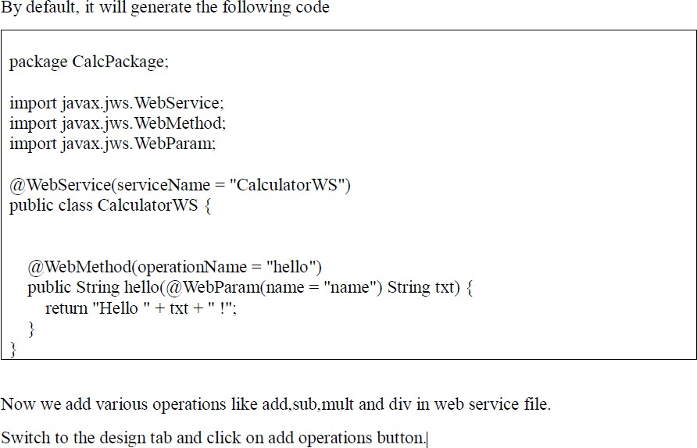
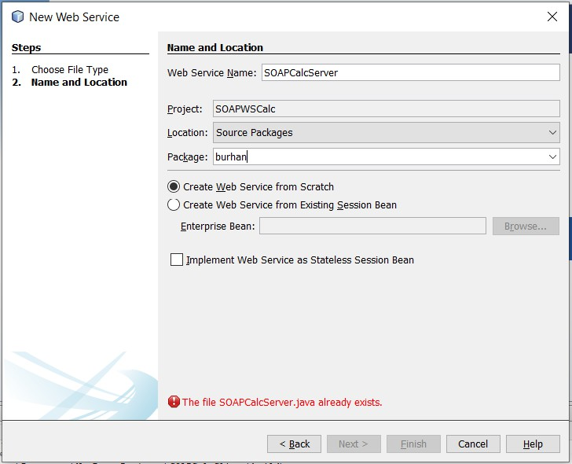
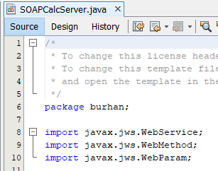

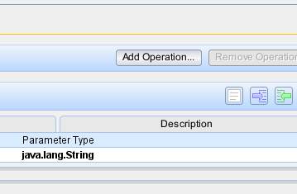
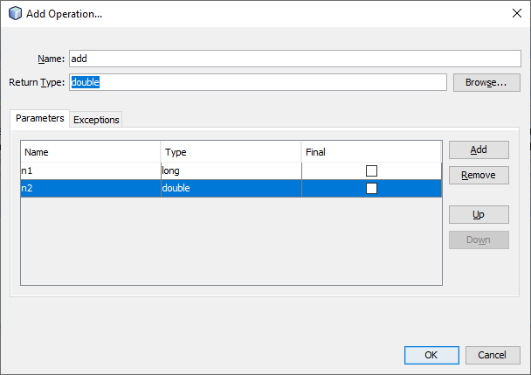
In the same way we add sub,mult and div operations.
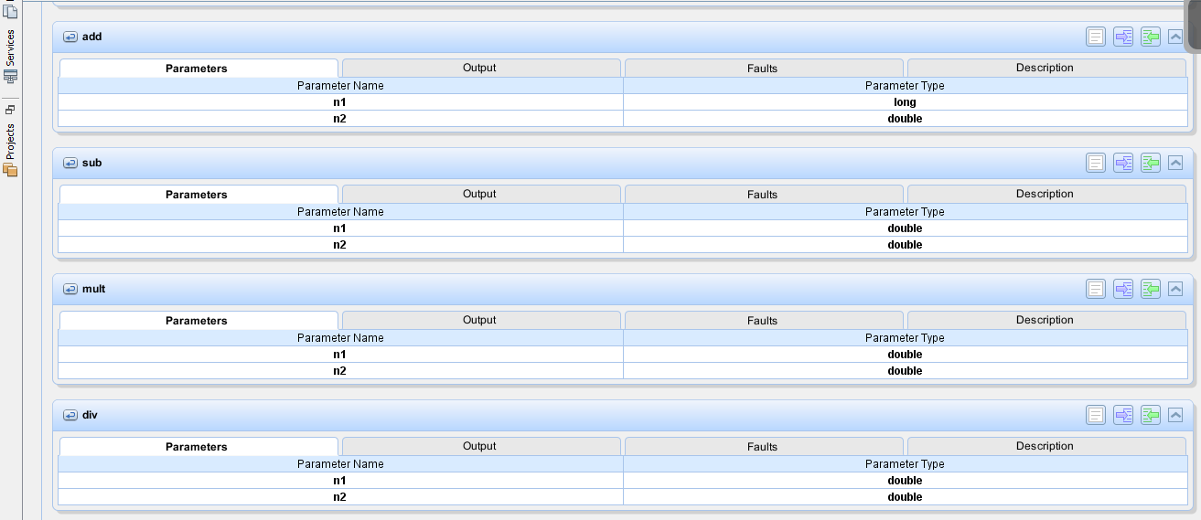

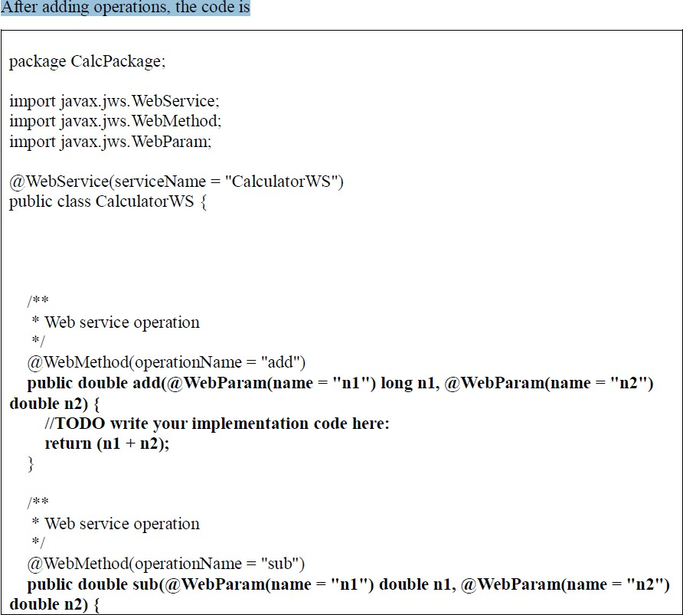
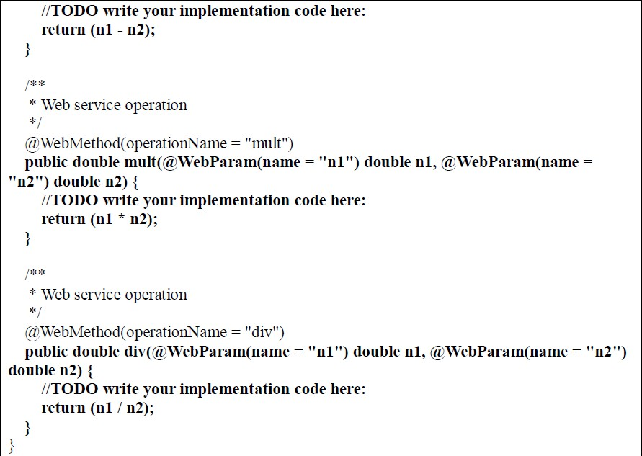

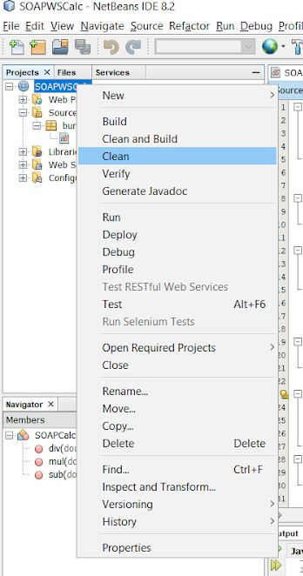
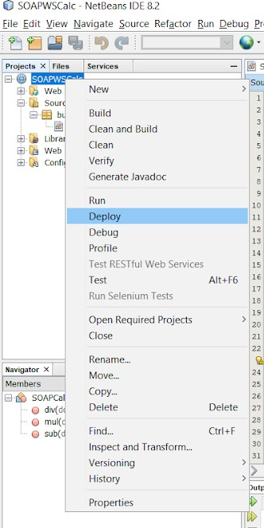
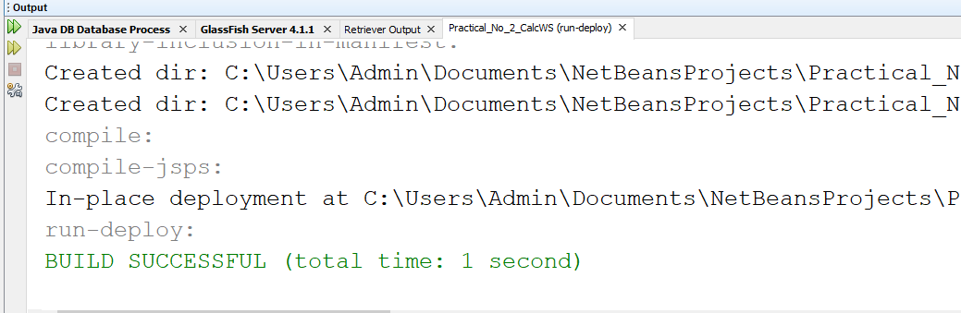
Step2: Now we deploy and test the web service Clean the web service project

Test the Web Service
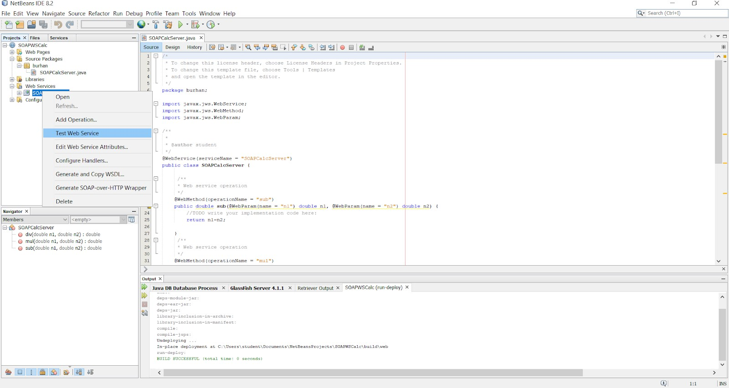

Server-Side Output:-

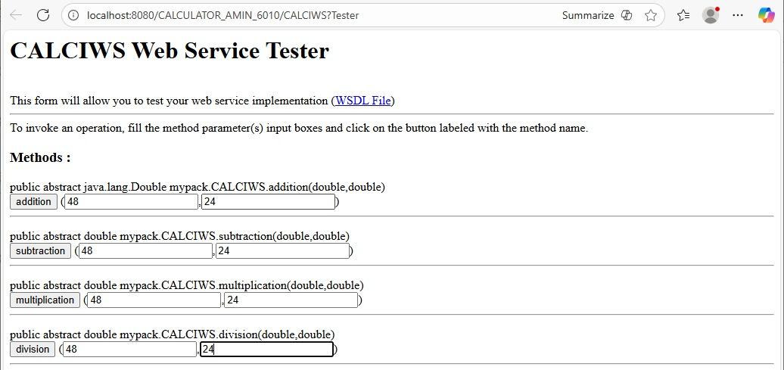

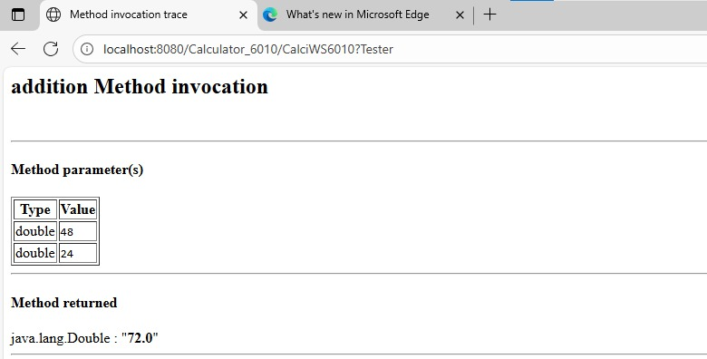

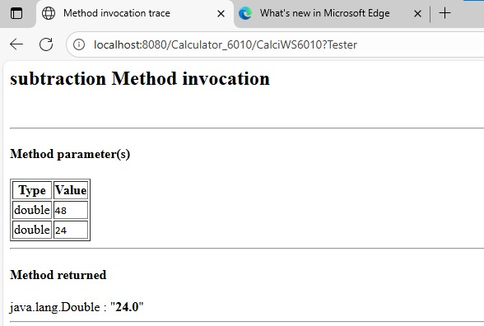

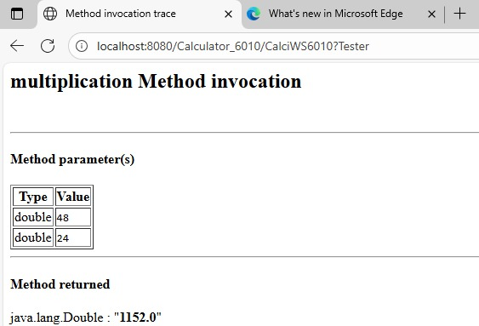

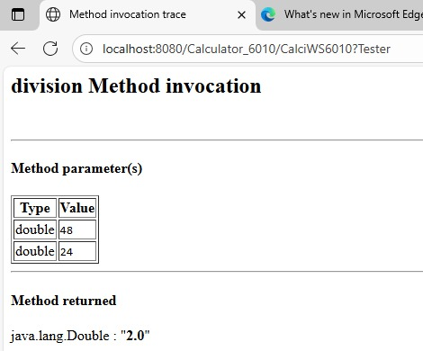

Step3: Now we create Web Service Client
File -> New Project -> Java Web -> Web Application
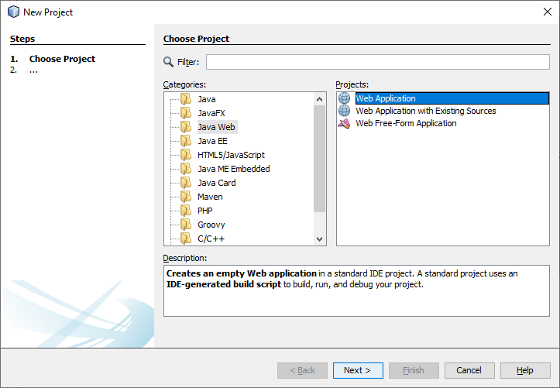

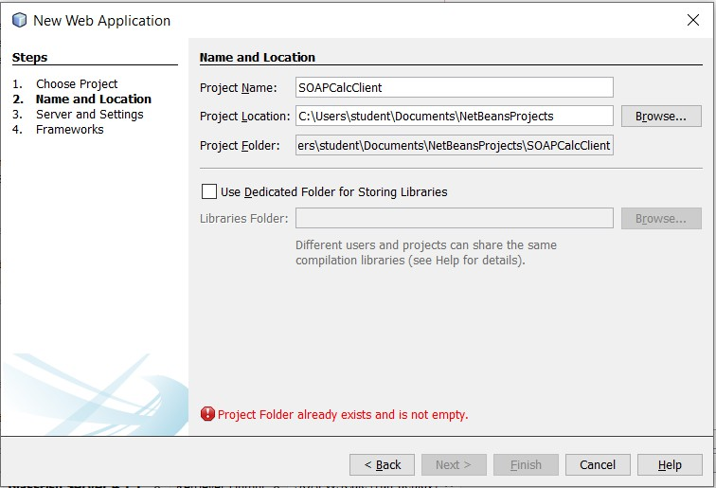

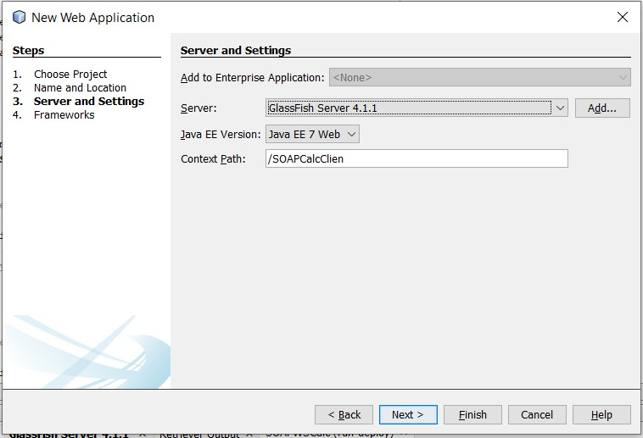

In client web project, we create two files input.html and output.jsp
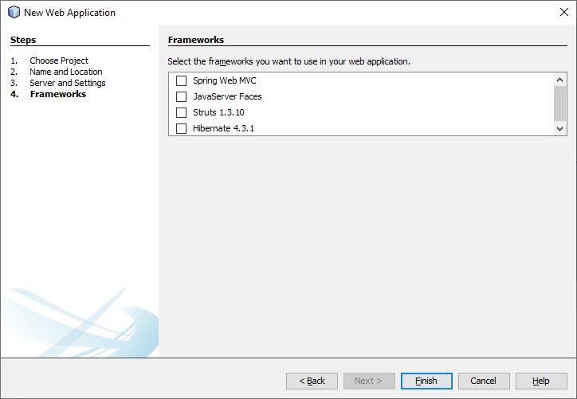

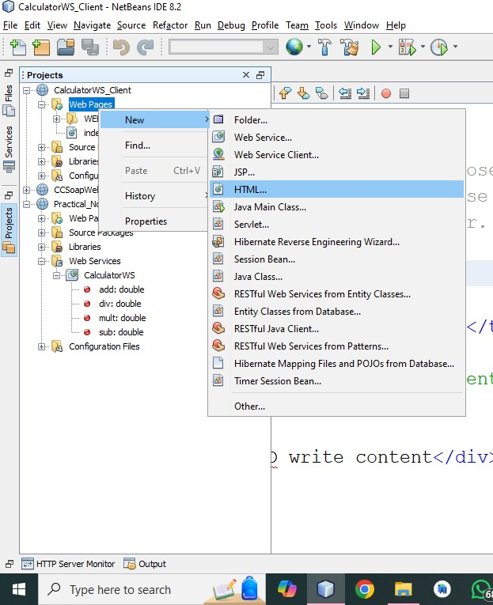

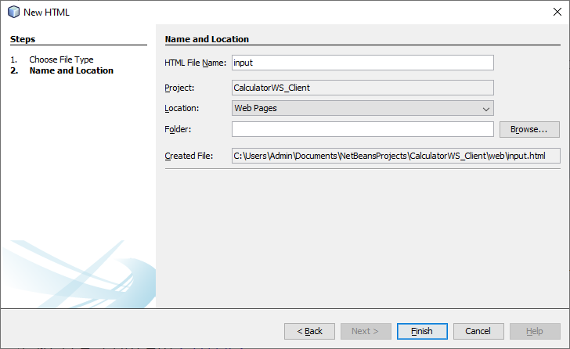

Input.html
<html>
<head>
<title>sahil shaikh 09 </title>
</head>
<body>
<h1> sahil shaikh 09 </h1>
<form action="output.jsp" method="POST">
Enter First Number : <input type="text" name="t1" value="" />
<br><br>
Enter Second Number: <input type="text" name="t2" value="" />
<br><br>
<input type="submit" value="Submit" />
</form>
</body>
</html>

Step4: Now we add reference of web service in client web application as follows

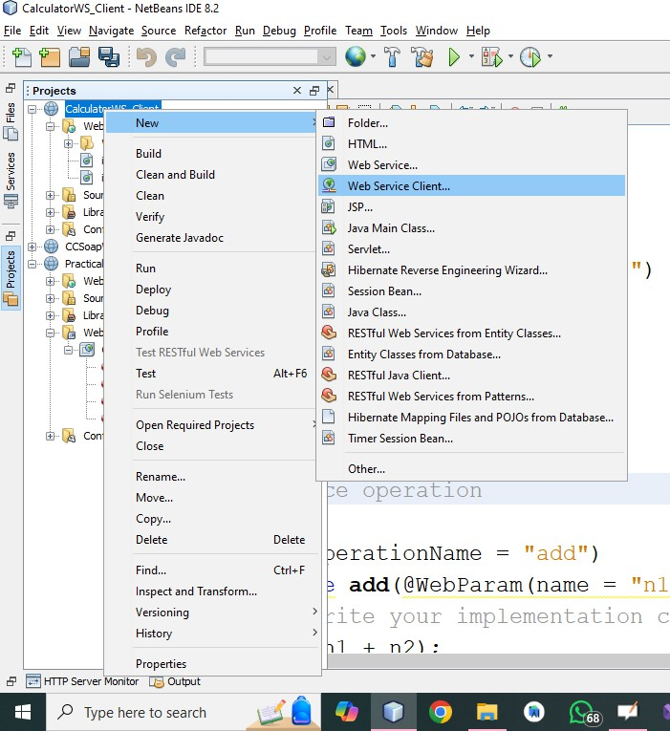
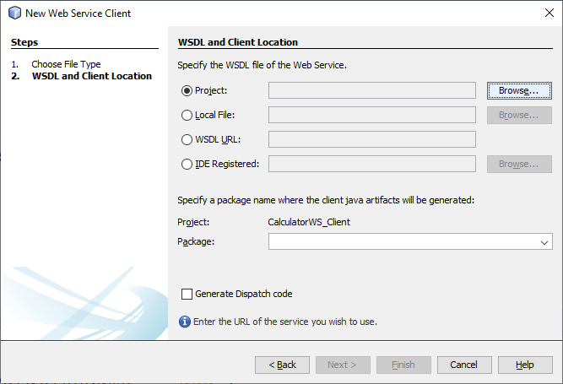
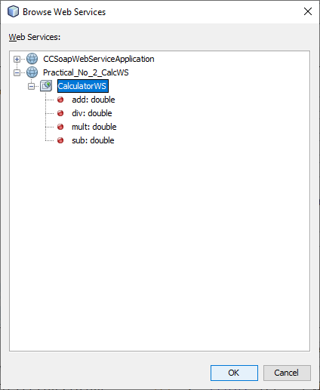

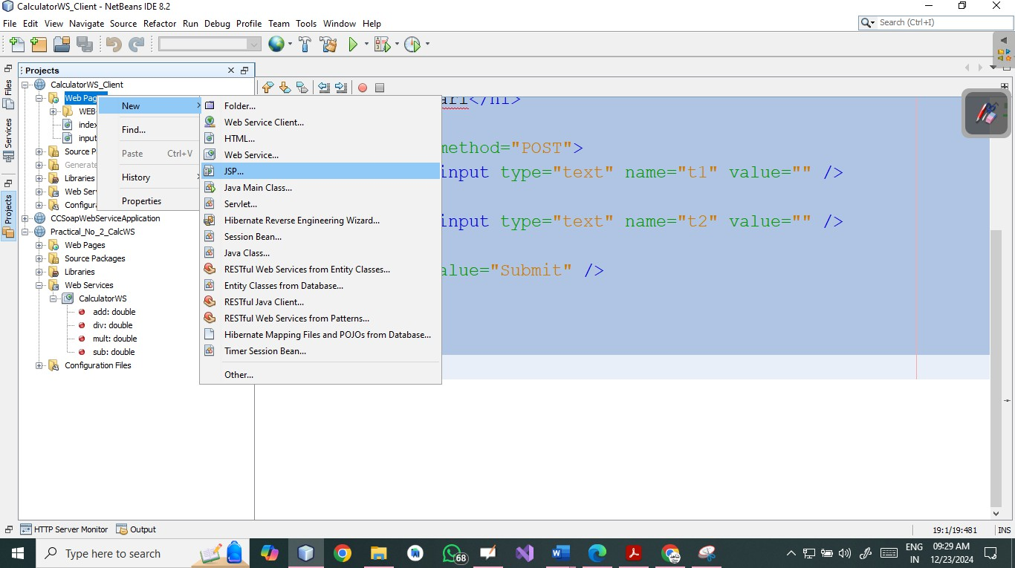
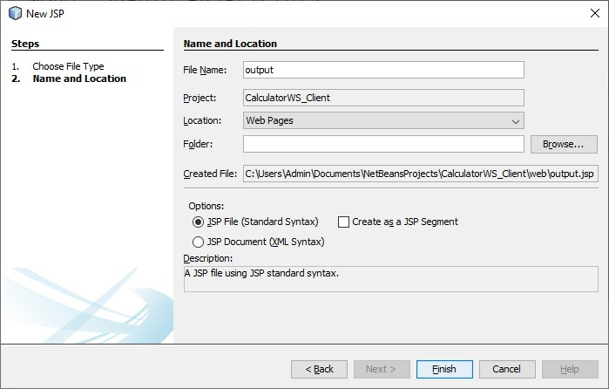
Drag and drop all four methods from web reference as
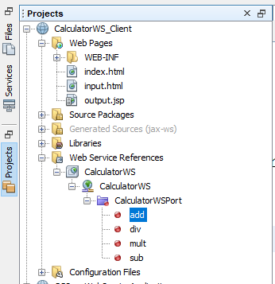

Output.jsp:-
<html>
<head>
<title> sahil shaikh 09 </title>
</head>
<body>
<h1> sahil shaikh 09 </h1>
<%-- start web service invocation --%><hr/>
<% try {
calcpackage.CalculatorWS_Service service = new calcpackage.CalculatorWS_Service();
calcpackage.CalculatorWS port = service.getCalculatorWSPort();
// TODO initialize WS operation arguments here
long n1 = Integer.parseInt(request.getParameter("t1")); double n2 = Integer.parseInt(request.getParameter("t2"));
// TODO process result here double result = port.add(n1, n2); out.println("Result = "+result);
} catch (Exception ex) {
// TODO handle custom exceptions here
}%>
<%-- end web service invocation --%><hr/>
<%-- start web service invocation --%><hr/>
<% try {
calcpackage.CalculatorWS_Service service = new calcpackage.CalculatorWS_Service();
calcpackage.CalculatorWS port = service.getCalculatorWSPort();
// TODO initialize WS operation arguments here
double n1 = Integer.parseInt(request.getParameter("t1")); double n2 = Integer.parseInt(request.getParameter("t2"));
// TODO process result here double result = port.sub(n1, n2); out.println("Result = "+result);
} catch (Exception ex) {
// TODO handle custom exceptions here
} %>
<%-- end web service invocation --%><hr/>
<%-- start web service invocation --%><hr/>
<%
try {
calcpackage.CalculatorWS_Service service = new calcpackage.CalculatorWS_Service();
calcpackage.CalculatorWS port = service.getCalculatorWSPort();
// TODO initialize WS operation arguments here
double n1 = Integer.parseInt(request.getParameter("t1"));

double n2 = Integer.parseInt(request.getParameter("t2"));
// TODO process result here double result = port.mult(n1, n2); out.println("Result = "+result);
} catch (Exception ex) {
// TODO handle custom exceptions here
}
%>
<%-- end web service invocation --%><hr/>
<%-- start web service invocation --%><hr/>
<%
try {
calcpackage.CalculatorWS_Service service = new calcpackage.CalculatorWS_Service();
calcpackage.CalculatorWS port = service.getCalculatorWSPort();
// TODO initialize WS operation arguments here
double n1 = Integer.parseInt(request.getParameter("t1")); double n2 = Integer.parseInt(request.getParameter("t2"));
// TODO process result here double result = port.div(n1, n2); out.println("Result = "+result);
} catch (Exception ex) {
// TODO handle custom exceptions here
} %>
<%-- end web service invocation --%><hr/>
</body>
</html>
Step5: Run the client and get output

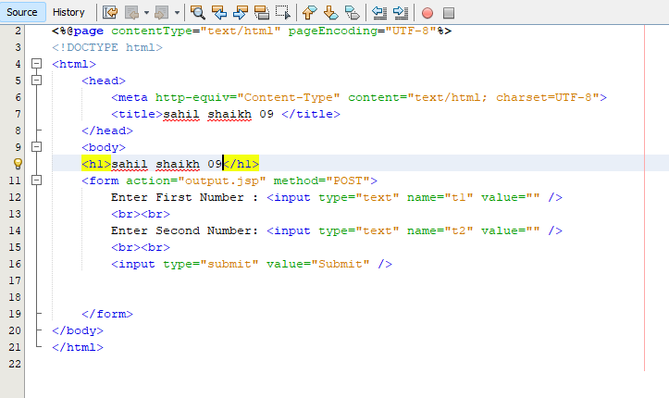

Output,jsp
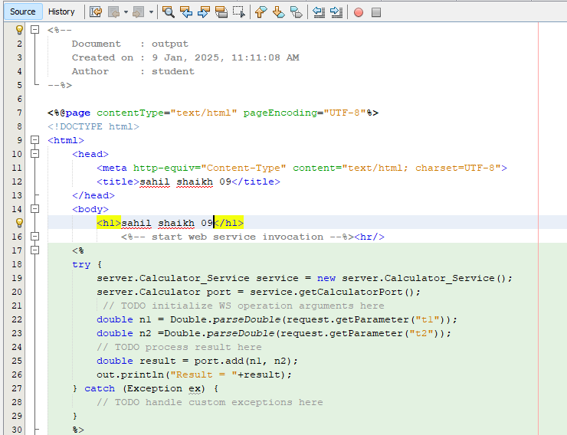

Client-Side Output:-

